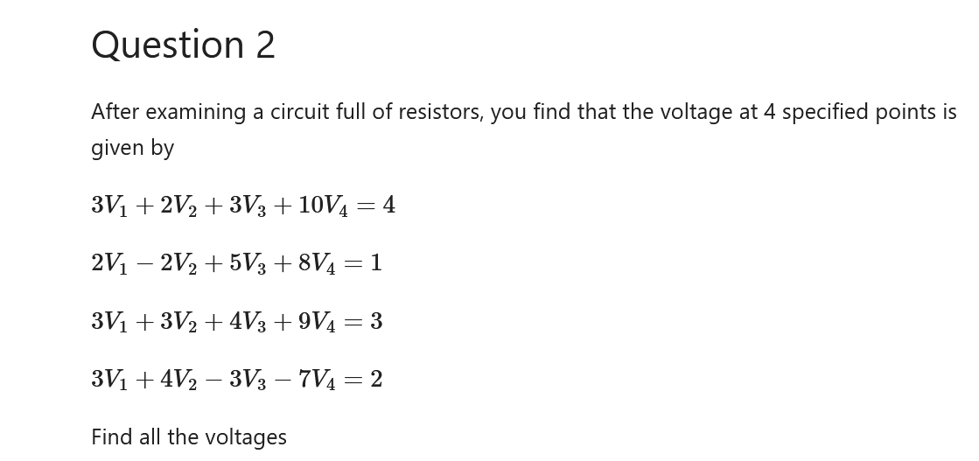

………………………………………….

a=np.array([[3,2,3,10],[2,-2,5,8],[3,3,4,9],[3,4,-3,-7]])

b=np.array([4,1,3,2])

c=np.linalg.solve(a,b)

print(c) #v1,v2,v3,v4

…………………………………………………………………………………….